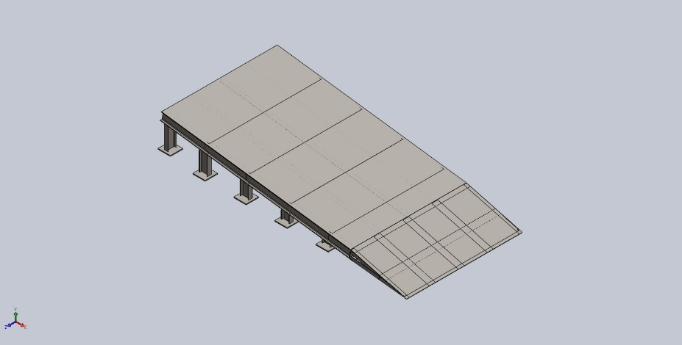
  Simulation of 03Assem1
  Date: 15 APRIL 2026
  Designer: BHARATI SABALE
  Study name: Static 1
  Analysis type: Static
  Table of Contents
  Description 1
  Assumptions 2
  Model Information 3
  Study Properties 13
  Units 13
  Material Properties 14
  Loads and Fixtures 17
  Connector Definitions 18
  Interaction Information 18
  Mesh information 19
  Sensor Details 19
  Resultant Forces 20
  Beams 21
  Study Results 29
  Conclusion 31

Description
No Data

Assumptions

Model Information

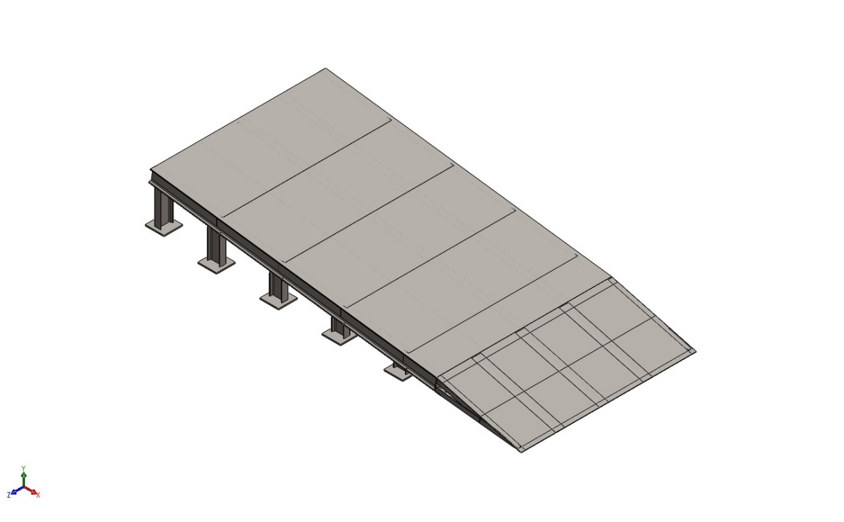
Model name: 03Assem1
Current Configuration: Default
Solid Bodies
Document Name and Reference | Treated As | Volumetric Properties | Document Path/Date Modified
Boss-Extrude1  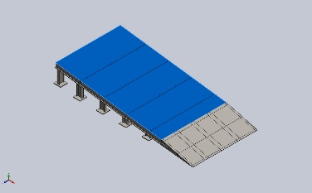 | Solid Body | Mass:126.66 kg  Volume:0.016135 m^3  Density:7,850 kg/m^3  Weight:1,241.27 N | E:\NIHVA AUTOMATION 2026\AUTOMATION\DOCK RAMP\dock ramp -03 - ASSA ABLOY\03CHEQURED PLATE.SLDPRT  Oct 19 18:40:39 2025
Boss-Extrude1  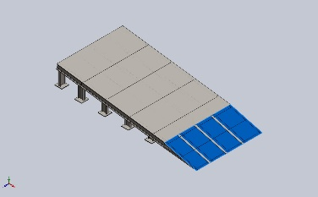 | Solid Body | Mass:38.465 kg  Volume:0.0049 m^3  Density:7,850 kg/m^3  Weight:376.957 N | E:\NIHVA AUTOMATION 2026\AUTOMATION\DOCK RAMP\dock ramp -03 - ASSA ABLOY\03SS PLATE.SLDPRT  Oct 21 06:22:15 2025
Boss-Extrude1  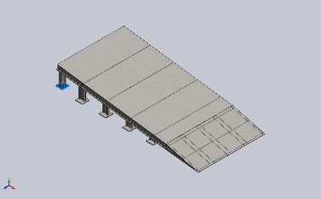 | Solid Body | Mass:1.76625 kg  Volume:0.000225 m^3  Density:7,850 kg/m^3  Weight:17.3092 N | E:\NIHVA AUTOMATION 2026\AUTOMATION\DOCK RAMP\dock ramp -03 - ASSA ABLOY\03bottom plate.SLDPRT  Oct 19 18:40:39 2025
Boss-Extrude1  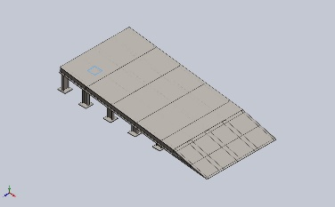 | Solid Body | Mass:1.76625 kg  Volume:0.000225 m^3  Density:7,850 kg/m^3  Weight:17.3092 N | E:\NIHVA AUTOMATION 2026\AUTOMATION\DOCK RAMP\dock ramp -03 - ASSA ABLOY\03bottom plate.SLDPRT  Oct 19 18:40:39 2025
Boss-Extrude1  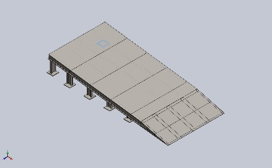 | Solid Body | Mass:1.76625 kg  Volume:0.000225 m^3  Density:7,850 kg/m^3  Weight:17.3092 N | E:\NIHVA AUTOMATION 2026\AUTOMATION\DOCK RAMP\dock ramp -03 - ASSA ABLOY\03bottom plate.SLDPRT  Oct 19 18:40:39 2025
Boss-Extrude1  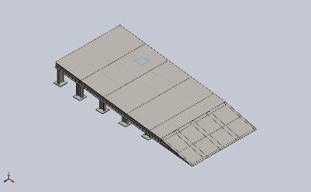 | Solid Body | Mass:1.76625 kg  Volume:0.000225 m^3  Density:7,850 kg/m^3  Weight:17.3092 N | E:\NIHVA AUTOMATION 2026\AUTOMATION\DOCK RAMP\dock ramp -03 - ASSA ABLOY\03bottom plate.SLDPRT  Oct 19 18:40:39 2025
Boss-Extrude1  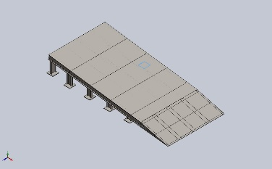 | Solid Body | Mass:1.76625 kg  Volume:0.000225 m^3  Density:7,850 kg/m^3  Weight:17.3092 N | E:\NIHVA AUTOMATION 2026\AUTOMATION\DOCK RAMP\dock ramp -03 - ASSA ABLOY\03bottom plate.SLDPRT  Oct 19 18:40:39 2025
Boss-Extrude1  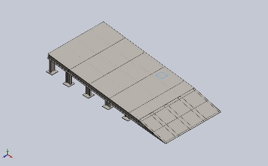 | Solid Body | Mass:1.76625 kg  Volume:0.000225 m^3  Density:7,850 kg/m^3  Weight:17.3092 N | E:\NIHVA AUTOMATION 2026\AUTOMATION\DOCK RAMP\dock ramp -03 - ASSA ABLOY\03bottom plate.SLDPRT  Oct 19 18:40:39 2025
Boss-Extrude1  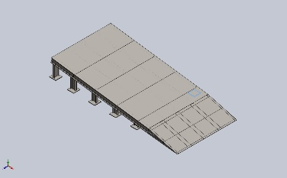 | Solid Body | Mass:1.76625 kg  Volume:0.000225 m^3  Density:7,850 kg/m^3  Weight:17.3092 N | E:\NIHVA AUTOMATION 2026\AUTOMATION\DOCK RAMP\dock ramp -03 - ASSA ABLOY\03bottom plate.SLDPRT  Oct 19 18:40:39 2025
Boss-Extrude1  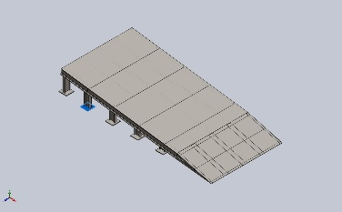 | Solid Body | Mass:1.76625 kg  Volume:0.000225 m^3  Density:7,850 kg/m^3  Weight:17.3092 N | E:\NIHVA AUTOMATION 2026\AUTOMATION\DOCK RAMP\dock ramp -03 - ASSA ABLOY\03bottom plate.SLDPRT  Oct 19 18:40:39 2025
Boss-Extrude1  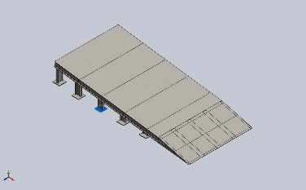 | Solid Body | Mass:1.76625 kg  Volume:0.000225 m^3  Density:7,850 kg/m^3  Weight:17.3092 N | E:\NIHVA AUTOMATION 2026\AUTOMATION\DOCK RAMP\dock ramp -03 - ASSA ABLOY\03bottom plate.SLDPRT  Oct 19 18:40:39 2025
Boss-Extrude1  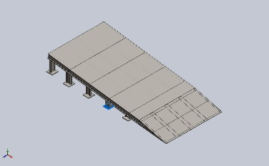 | Solid Body | Mass:1.76625 kg  Volume:0.000225 m^3  Density:7,850 kg/m^3  Weight:17.3092 N | E:\NIHVA AUTOMATION 2026\AUTOMATION\DOCK RAMP\dock ramp -03 - ASSA ABLOY\03bottom plate.SLDPRT  Oct 19 18:40:39 2025
Boss-Extrude1  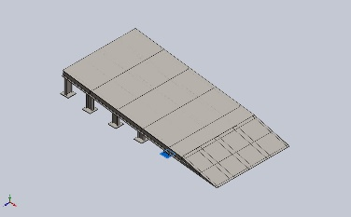 | Solid Body | Mass:1.76625 kg  Volume:0.000225 m^3  Density:7,850 kg/m^3  Weight:17.3092 N | E:\NIHVA AUTOMATION 2026\AUTOMATION\DOCK RAMP\dock ramp -03 - ASSA ABLOY\03bottom plate.SLDPRT  Oct 19 18:40:39 2025
Beam Bodies:
Document Name and Reference | Formulation | Properties | Document Path/Date Modified
SolidBody 1(Trim/Extend1[5])  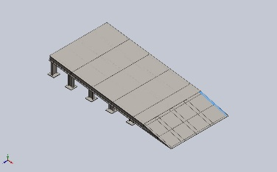 | Beam – Uniform C/S | Section Standard-  Section Area: 0.000319635m^2  Length:650.834mm  Volume:0.000155116m^3  Mass Density:7,850kg/m^3  Mass:1.21766kg  Weight:11.9331N | E:\NIHVA AUTOMATION 2026\AUTOMATION\DOCK RAMP\dock ramp -03 - ASSA ABLOY\03DOCK RAMP2.SLDPRT  Oct 21 06:22:14 2025
SolidBody 2(Cut-Extrude2)  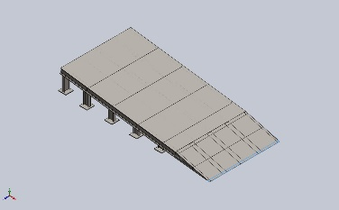 | Beam – Uniform C/S | Section Standard-weldment profiles/iso/angle iron  Section Area: 8.65191e-05m^2  Length:1,400mm  Volume:0.000121127m^3  Mass Density:7,850kg/m^3  Mass:0.950845kg  Weight:9.31828N | E:\NIHVA AUTOMATION 2026\AUTOMATION\DOCK RAMP\dock ramp -03 - ASSA ABLOY\03DOCK RAMP2.SLDPRT  Oct 21 06:22:14 2025
SolidBody 3(Cut-Extrude4)  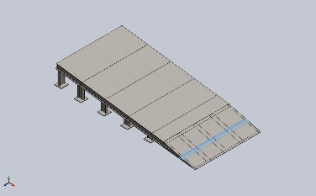 | Beam – Uniform C/S | Section Standard-weldment profiles/iso/angle iron  Section Area: 0.000715454m^2  Length:1,400mm  Volume:0.00100164m^3  Mass Density:7,850kg/m^3  Mass:7.86284kg  Weight:77.0558N | E:\NIHVA AUTOMATION 2026\AUTOMATION\DOCK RAMP\dock ramp -03 - ASSA ABLOY\03DOCK RAMP2.SLDPRT  Oct 21 06:22:14 2025
SolidBody 4(Trim/Extend1[1])  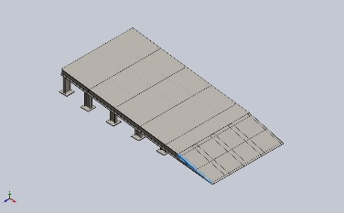 | Beam – Uniform C/S | Section Standard-  Section Area: 0.000319635m^2  Length:650.834mm  Volume:0.000155116m^3  Mass Density:7,850kg/m^3  Mass:1.21766kg  Weight:11.9331N | E:\NIHVA AUTOMATION 2026\AUTOMATION\DOCK RAMP\dock ramp -03 - ASSA ABLOY\03DOCK RAMP2.SLDPRT  Oct 21 06:22:14 2025
SolidBody 5(Trim/Extend1[2])  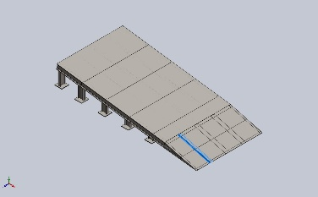 | Beam – Uniform C/S | Section Standard-  Section Area: 0.000856274m^2  Length:693.682mm  Volume:0.000479396m^3  Mass Density:7,850kg/m^3  Mass:3.76326kg  Weight:36.88N | E:\NIHVA AUTOMATION 2026\AUTOMATION\DOCK RAMP\dock ramp -03 - ASSA ABLOY\03DOCK RAMP2.SLDPRT  Oct 21 06:22:14 2025
SolidBody 6(Trim/Extend1[4])  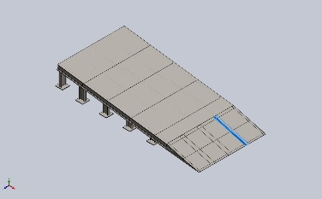 | Beam – Uniform C/S | Section Standard-  Section Area: 0.000856274m^2  Length:693.682mm  Volume:0.000479396m^3  Mass Density:7,850kg/m^3  Mass:3.76326kg  Weight:36.88N | E:\NIHVA AUTOMATION 2026\AUTOMATION\DOCK RAMP\dock ramp -03 - ASSA ABLOY\03DOCK RAMP2.SLDPRT  Oct 21 06:22:14 2025
SolidBody 7(Trim/Extend1[3])  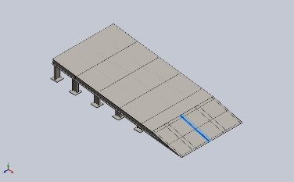 | Beam – Uniform C/S | Section Standard-  Section Area: 0.000856274m^2  Length:693.682mm  Volume:0.000479396m^3  Mass Density:7,850kg/m^3  Mass:3.76326kg  Weight:36.88N | E:\NIHVA AUTOMATION 2026\AUTOMATION\DOCK RAMP\dock ramp -03 - ASSA ABLOY\03DOCK RAMP2.SLDPRT  Oct 21 06:22:14 2025
SolidBody 8(C channel 100 X 10(1))  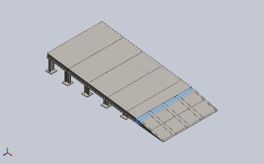 | Beam – Uniform C/S | Section Standard-weldment profiles/iso/c channel  Section Area: 0.00131018m^2  Length:1,400mm  Volume:0.00183425m^3  Mass Density:7,850kg/m^3  Mass:14.3988kg  Weight:141.109N | E:\NIHVA AUTOMATION 2026\AUTOMATION\DOCK RAMP\dock ramp -03 - ASSA ABLOY\03DOCK RAMP2.SLDPRT  Oct 21 06:22:14 2025
SolidBody 9(Angle iron 35 X 35 X 5(1)[1])  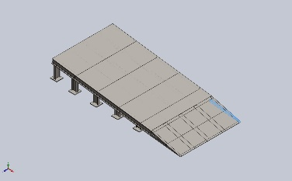 | Beam – Uniform C/S | Section Standard-weldment profiles/iso/angle iron  Section Area: 0.000319635m^2  Length:676.965mm  Volume:0.000201915m^3  Mass Density:7,850kg/m^3  Mass:1.58504kg  Weight:15.5333N | E:\NIHVA AUTOMATION 2026\AUTOMATION\DOCK RAMP\dock ramp -03 - ASSA ABLOY\03DOCK RAMP2.SLDPRT  Oct 21 06:22:14 2025
SolidBody 10(Angle iron 35 X 35 X 5(1)[2])  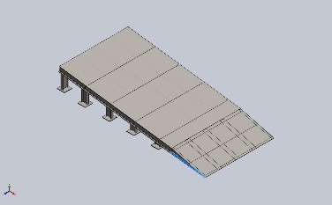 | Beam – Uniform C/S | Section Standard-weldment profiles/iso/angle iron  Section Area: 0.000319635m^2  Length:668.363mm  Volume:0.00020192m^3  Mass Density:7,850kg/m^3  Mass:1.58507kg  Weight:15.5337N | E:\NIHVA AUTOMATION 2026\AUTOMATION\DOCK RAMP\dock ramp -03 - ASSA ABLOY\03DOCK RAMP2.SLDPRT  Oct 21 06:22:14 2025
SolidBody 1(Cut-Extrude5[5])  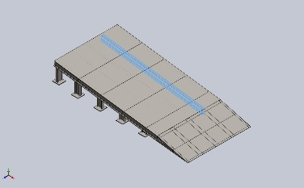 | Beam – Uniform C/S | Section Standard-weldment profiles/iso/sb beam  Section Area: 0.00109003m^2  Length:2,265.04mm  Volume:0.0024703m^3  Mass Density:7,850kg/m^3  Mass:19.3919kg  Weight:190.04N | E:\NIHVA AUTOMATION 2026\AUTOMATION\DOCK RAMP\dock ramp -03 - ASSA ABLOY\03sissior lift ramp.SLDPRT  Oct 21 06:22:14 2025
SolidBody 2(C channel 100 X 10(1)[4])  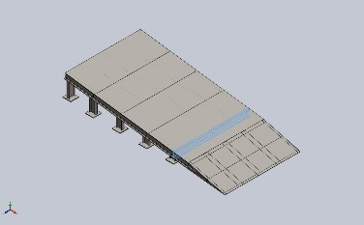 | Beam – Uniform C/S | Section Standard-weldment profiles/iso/c channel  Section Area: 0.00131018m^2  Length:1,350mm  Volume:0.00176877m^3  Mass Density:7,850kg/m^3  Mass:13.8849kg  Weight:136.072N | E:\NIHVA AUTOMATION 2026\AUTOMATION\DOCK RAMP\dock ramp -03 - ASSA ABLOY\03sissior lift ramp.SLDPRT  Oct 21 06:22:14 2025
SolidBody 3(Cut-Extrude5[1])  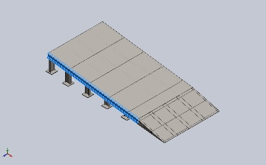 | Beam – Uniform C/S | Section Standard-weldment profiles/iso/sb beam  Section Area: 0.00109003m^2  Length:2,307.92mm  Volume:0.00251577m^3  Mass Density:7,850kg/m^3  Mass:19.7488kg  Weight:193.539N | E:\NIHVA AUTOMATION 2026\AUTOMATION\DOCK RAMP\dock ramp -03 - ASSA ABLOY\03sissior lift ramp.SLDPRT  Oct 21 06:22:14 2025
SolidBody 4(Cut-Extrude5[3])  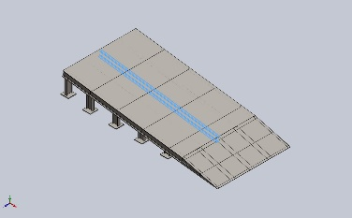 | Beam – Uniform C/S | Section Standard-weldment profiles/iso/sb beam  Section Area: 0.00109003m^2  Length:2,282.6mm  Volume:0.00248845m^3  Mass Density:7,850kg/m^3  Mass:19.5343kg  Weight:191.436N | E:\NIHVA AUTOMATION 2026\AUTOMATION\DOCK RAMP\dock ramp -03 - ASSA ABLOY\03sissior lift ramp.SLDPRT  Oct 21 06:22:14 2025
SolidBody 5(C channel 100 X 10(1)[1])  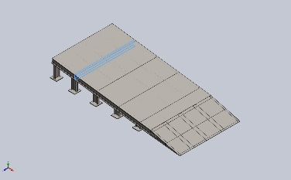 | Beam – Uniform C/S | Section Standard-weldment profiles/iso/c channel  Section Area: 0.00131018m^2  Length:1,350mm  Volume:0.00176877m^3  Mass Density:7,850kg/m^3  Mass:13.8849kg  Weight:136.072N | E:\NIHVA AUTOMATION 2026\AUTOMATION\DOCK RAMP\dock ramp -03 - ASSA ABLOY\03sissior lift ramp.SLDPRT  Oct 21 06:22:14 2025
SolidBody 6(Cut-Extrude2[6])  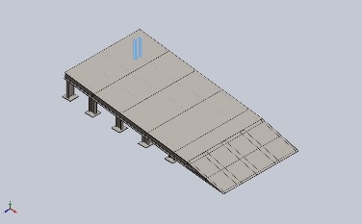 | Beam – Uniform C/S | Section Standard-weldment profiles/iso/sb beam  Section Area: 0.00109003m^2  Length:300mm  Volume:0.000327009m^3  Mass Density:7,850kg/m^3  Mass:2.56702kg  Weight:25.1568N | E:\NIHVA AUTOMATION 2026\AUTOMATION\DOCK RAMP\dock ramp -03 - ASSA ABLOY\03sissior lift ramp.SLDPRT  Oct 21 06:22:14 2025
SolidBody 7(Cut-Extrude2[8])  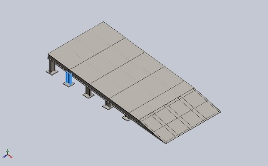 | Beam – Uniform C/S | Section Standard-weldment profiles/iso/sb beam  Section Area: 0.00109003m^2  Length:234.243mm  Volume:0.000255332m^3  Mass Density:7,850kg/m^3  Mass:2.00436kg  Weight:19.6427N | E:\NIHVA AUTOMATION 2026\AUTOMATION\DOCK RAMP\dock ramp -03 - ASSA ABLOY\03sissior lift ramp.SLDPRT  Oct 21 06:22:14 2025
SolidBody 8(Cut-Extrude2[9])  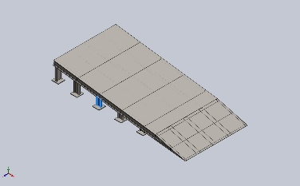 | Beam – Uniform C/S | Section Standard-weldment profiles/iso/sb beam  Section Area: 0.00109003m^2  Length:168.486mm  Volume:0.000183655m^3  Mass Density:7,850kg/m^3  Mass:1.44169kg  Weight:14.1285N | E:\NIHVA AUTOMATION 2026\AUTOMATION\DOCK RAMP\dock ramp -03 - ASSA ABLOY\03sissior lift ramp.SLDPRT  Oct 21 06:22:14 2025
SolidBody 9(Cut-Extrude2[5])  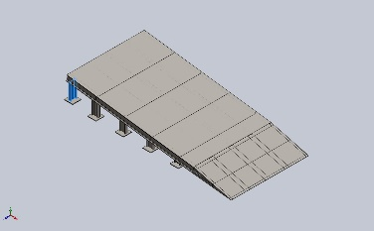 | Beam – Uniform C/S | Section Standard-weldment profiles/iso/sb beam  Section Area: 0.00109003m^2  Length:300mm  Volume:0.000327009m^3  Mass Density:7,850kg/m^3  Mass:2.56702kg  Weight:25.1568N | E:\NIHVA AUTOMATION 2026\AUTOMATION\DOCK RAMP\dock ramp -03 - ASSA ABLOY\03sissior lift ramp.SLDPRT  Oct 21 06:22:14 2025
SolidBody 10(Cut-Extrude2[10])  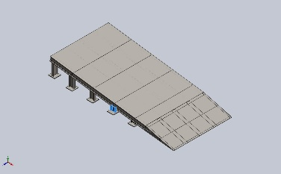 | Beam – Uniform C/S | Section Standard-weldment profiles/iso/sb beam  Section Area: 0.00109003m^2  Length:102.728mm  Volume:0.000111977m^3  Mass Density:7,850kg/m^3  Mass:0.879021kg  Weight:8.61441N | E:\NIHVA AUTOMATION 2026\AUTOMATION\DOCK RAMP\dock ramp -03 - ASSA ABLOY\03sissior lift ramp.SLDPRT  Oct 21 06:22:14 2025
SolidBody 11(C channel 100 X 10(1)[3])  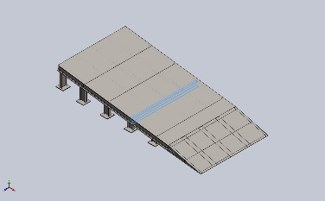 | Beam – Uniform C/S | Section Standard-weldment profiles/iso/c channel  Section Area: 0.00131018m^2  Length:1,350mm  Volume:0.00176877m^3  Mass Density:7,850kg/m^3  Mass:13.8849kg  Weight:136.072N | E:\NIHVA AUTOMATION 2026\AUTOMATION\DOCK RAMP\dock ramp -03 - ASSA ABLOY\03sissior lift ramp.SLDPRT  Oct 21 06:22:14 2025
SolidBody 12(Cut-Extrude2[11])  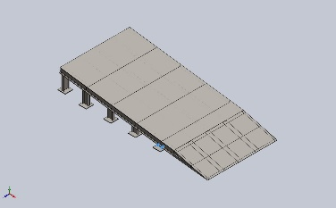 | Beam – Uniform C/S | Section Standard-weldment profiles/iso/sb beam  Section Area: 0.000166371m^2  Length:92.0026mm  Volume:4.02998e-05m^3  Mass Density:7,850kg/m^3  Mass:0.316354kg  Weight:3.10027N | E:\NIHVA AUTOMATION 2026\AUTOMATION\DOCK RAMP\dock ramp -03 - ASSA ABLOY\03sissior lift ramp.SLDPRT  Oct 21 06:22:14 2025
SolidBody 13(Cut-Extrude5[2])  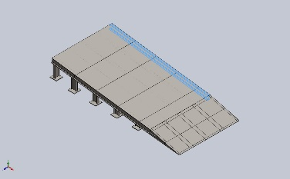 | Beam – Uniform C/S | Section Standard-weldment profiles/iso/sb beam  Section Area: 0.00109003m^2  Length:2,307.92mm  Volume:0.00251577m^3  Mass Density:7,850kg/m^3  Mass:19.7488kg  Weight:193.539N | E:\NIHVA AUTOMATION 2026\AUTOMATION\DOCK RAMP\dock ramp -03 - ASSA ABLOY\03sissior lift ramp.SLDPRT  Oct 21 06:22:14 2025
SolidBody 14(Cut-Extrude2[7])  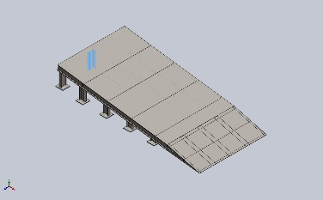 | Beam – Uniform C/S | Section Standard-weldment profiles/iso/sb beam  Section Area: 0.00109003m^2  Length:300mm  Volume:0.000327009m^3  Mass Density:7,850kg/m^3  Mass:2.56702kg  Weight:25.1568N | E:\NIHVA AUTOMATION 2026\AUTOMATION\DOCK RAMP\dock ramp -03 - ASSA ABLOY\03sissior lift ramp.SLDPRT  Oct 21 06:22:14 2025
SolidBody 15(Sb beam 100 X 8(1)[4])  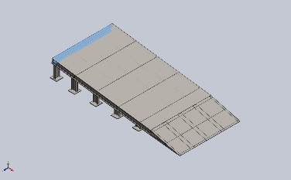 | Beam – Uniform C/S | Section Standard-weldment profiles/iso/sb beam  Section Area: 0.00109003m^2  Length:1,300mm  Volume:0.00141704m^3  Mass Density:7,850kg/m^3  Mass:11.1238kg  Weight:109.013N | E:\NIHVA AUTOMATION 2026\AUTOMATION\DOCK RAMP\dock ramp -03 - ASSA ABLOY\03sissior lift ramp.SLDPRT  Oct 21 06:22:14 2025
SolidBody 16(Cut-Extrude2[12])  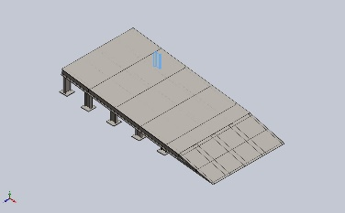 | Beam – Uniform C/S | Section Standard-weldment profiles/iso/sb beam  Section Area: 0.00109003m^2  Length:234.248mm  Volume:0.000255338m^3  Mass Density:7,850kg/m^3  Mass:2.0044kg  Weight:19.6431N | E:\NIHVA AUTOMATION 2026\AUTOMATION\DOCK RAMP\dock ramp -03 - ASSA ABLOY\03sissior lift ramp.SLDPRT  Oct 21 06:22:14 2025
SolidBody 17(Cut-Extrude2[13])  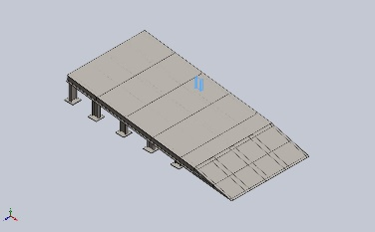 | Beam – Uniform C/S | Section Standard-weldment profiles/iso/sb beam  Section Area: 0.00109003m^2  Length:168.491mm  Volume:0.00018366m^3  Mass Density:7,850kg/m^3  Mass:1.44173kg  Weight:14.129N | E:\NIHVA AUTOMATION 2026\AUTOMATION\DOCK RAMP\dock ramp -03 - ASSA ABLOY\03sissior lift ramp.SLDPRT  Oct 21 06:22:14 2025
SolidBody 18(Cut-Extrude5[4])  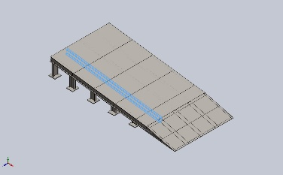 | Beam – Uniform C/S | Section Standard-weldment profiles/iso/sb beam  Section Area: 0.00109003m^2  Length:2,265.04mm  Volume:0.0024703m^3  Mass Density:7,850kg/m^3  Mass:19.3919kg  Weight:190.04N | E:\NIHVA AUTOMATION 2026\AUTOMATION\DOCK RAMP\dock ramp -03 - ASSA ABLOY\03sissior lift ramp.SLDPRT  Oct 21 06:22:14 2025
SolidBody 19(Cut-Extrude2[14])  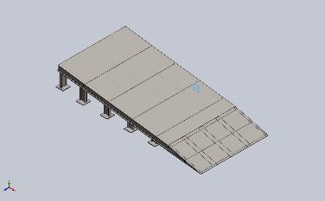 | Beam – Uniform C/S | Section Standard-weldment profiles/iso/sb beam  Section Area: 0.00109003m^2  Length:102.734mm  Volume:0.000111983m^3  Mass Density:7,850kg/m^3  Mass:0.879066kg  Weight:8.61484N | E:\NIHVA AUTOMATION 2026\AUTOMATION\DOCK RAMP\dock ramp -03 - ASSA ABLOY\03sissior lift ramp.SLDPRT  Oct 21 06:22:14 2025
SolidBody 20(Cut-Extrude2[15])  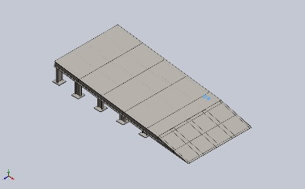 | Beam – Uniform C/S | Section Standard-weldment profiles/iso/sb beam  Section Area: 0.000166394m^2  Length:92.0026mm  Volume:4.03055e-05m^3  Mass Density:7,850kg/m^3  Mass:0.316398kg  Weight:3.1007N | E:\NIHVA AUTOMATION 2026\AUTOMATION\DOCK RAMP\dock ramp -03 - ASSA ABLOY\03sissior lift ramp.SLDPRT  Oct 21 06:22:14 2025
SolidBody 21(Cut-Extrude5[6])  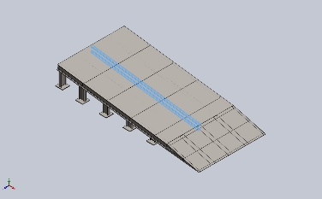 | Beam – Uniform C/S | Section Standard-weldment profiles/iso/sb beam  Section Area: 0.00109003m^2  Length:2,265.04mm  Volume:0.0024703m^3  Mass Density:7,850kg/m^3  Mass:19.3919kg  Weight:190.04N | E:\NIHVA AUTOMATION 2026\AUTOMATION\DOCK RAMP\dock ramp -03 - ASSA ABLOY\03sissior lift ramp.SLDPRT  Oct 21 06:22:14 2025
SolidBody 22(C channel 100 X 10(1)[2])  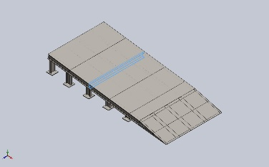 | Beam – Uniform C/S | Section Standard-weldment profiles/iso/c channel  Section Area: 0.00131018m^2  Length:1,350mm  Volume:0.00176877m^3  Mass Density:7,850kg/m^3  Mass:13.8849kg  Weight:136.072N | E:\NIHVA AUTOMATION 2026\AUTOMATION\DOCK RAMP\dock ramp -03 - ASSA ABLOY\03sissior lift ramp.SLDPRT  Oct 21 06:22:14 2025

Study Properties
Study name | Static 1
Analysis type | Static
Mesh type | Mixed Mesh
Thermal Effect: | On
Thermal option | Include temperature loads
Zero strain temperature | 298 Kelvin
Include fluid pressure effects from SOLIDWORKS Flow Simulation | Off
Solver type | Automatic
Inplane Effect: | Off
Soft Spring: | Off
Inertial Relief: | Off
Incompatible bonding options | Automatic
Large displacement | Off
Compute free body forces | On
Friction | Off
Use Adaptive Method: | Off
Result folder | SOLIDWORKS document (E:\NIHVA AUTOMATION 2026\AUTOMATION\DOCK RAMP\dock ramp -03 - ASSA ABLOY)

Units
Unit system: | SI (MKS)
Length/Displacement | mm
Temperature | Kelvin
Angular velocity | Rad/sec
Pressure/Stress | N/m^2

Material Properties
Model Reference | Properties | Components
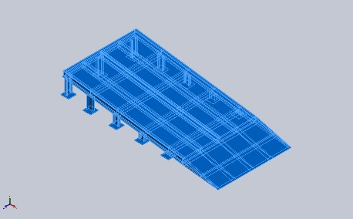 |  | SolidBody 1(Boss-Extrude1)(03CHEQURED PLATE-1),  SolidBody 1(Trim/Extend1[5])(03DOCK RAMP2-1),  SolidBody 2(Cut-Extrude2)(03DOCK RAMP2-1),  SolidBody 3(Cut-Extrude4)(03DOCK RAMP2-1),  SolidBody 4(Trim/Extend1[1])(03DOCK RAMP2-1),  SolidBody 5(Trim/Extend1[2])(03DOCK RAMP2-1),  SolidBody 6(Trim/Extend1[4])(03DOCK RAMP2-1),  SolidBody 7(Trim/Extend1[3])(03DOCK RAMP2-1),  SolidBody 8(C channel 100 X 10(1))(03DOCK RAMP2-1),  SolidBody 9(Angle iron 35 X 35 X 5(1)[1])(03DOCK RAMP2-1),  SolidBody 10(Angle iron 35 X 35 X 5(1)[2])(03DOCK RAMP2-1),  SolidBody 1(Boss-Extrude1)(03SS PLATE-1),  SolidBody 1(Boss-Extrude1)(03bottom plate-1),  SolidBody 1(Boss-Extrude1)(03bottom plate-13),  SolidBody 1(Boss-Extrude1)(03bottom plate-15),  SolidBody 1(Boss-Extrude1)(03bottom plate-17),  SolidBody 1(Boss-Extrude1)(03bottom plate-19),  SolidBody 1(Boss-Extrude1)(03bottom plate-21),  SolidBody 1(Boss-Extrude1)(03bottom plate-23),  SolidBody 1(Boss-Extrude1)(03bottom plate-3),  SolidBody 1(Boss-Extrude1)(03bottom plate-5),  SolidBody 1(Boss-Extrude1)(03bottom plate-7),  SolidBody 1(Boss-Extrude1)(03bottom plate-9),  SolidBody 1(Cut-Extrude5[5])(03sissior lift ramp-1),  SolidBody 2(C channel 100 X 10(1)[4])(03sissior lift ramp-1),  SolidBody 3(Cut-Extrude5[1])(03sissior lift ramp-1),  SolidBody 4(Cut-Extrude5[3])(03sissior lift ramp-1),  SolidBody 5(C channel 100 X 10(1)[1])(03sissior lift ramp-1),  SolidBody 6(Cut-Extrude2[6])(03sissior lift ramp-1),  SolidBody 7(Cut-Extrude2[8])(03sissior lift ramp-1),  SolidBody 8(Cut-Extrude2[9])(03sissior lift ramp-1),  SolidBody 9(Cut-Extrude2[5])(03sissior lift ramp-1),  SolidBody 10(Cut-Extrude2[10])(03sissior lift ramp-1),  SolidBody 11(C channel 100 X 10(1)[3])(03sissior lift ramp-1),  SolidBody 12(Cut-Extrude2[11])(03sissior lift ramp-1),  SolidBody 13(Cut-Extrude5[2])(03sissior lift ramp-1),  SolidBody 14(Cut-Extrude2[7])(03sissior lift ramp-1),  SolidBody 15(Sb beam 100 X 8(1)[4])(03sissior lift ramp-1),  SolidBody 16(Cut-Extrude2[12])(03sissior lift ramp-1),  SolidBody 17(Cut-Extrude2[13])(03sissior lift ramp-1),  SolidBody 18(Cut-Extrude5[4])(03sissior lift ramp-1),  SolidBody 19(Cut-Extrude2[14])(03sissior lift ramp-1),  SolidBody 20(Cut-Extrude2[15])(03sissior lift ramp-1),  SolidBody 21(Cut-Extrude5[6])(03sissior lift ramp-1),  SolidBody 22(C channel 100 X 10(1)[2])(03sissior lift ramp-1)
  Name: | AISI 1045 Steel, cold drawn
  Model type: | Linear Elastic Isotropic
  Default failure criterion: | Max von Mises Stress
  Yield strength: | 5.3e+08 N/m^2
  Tensile strength: | 6.25e+08 N/m^2
  Elastic modulus: | 2.05e+11 N/m^2
  Poisson's ratio: | 0.29
  Mass density: | 7,850 kg/m^3
  Shear modulus: | 8e+10 N/m^2
  Thermal expansion coefficient: | 1.15e-05 /Kelvin
Curve Data:N/A

Loads and Fixtures
Fixture name | Fixture Image | Fixture Details
Fixed-1 | 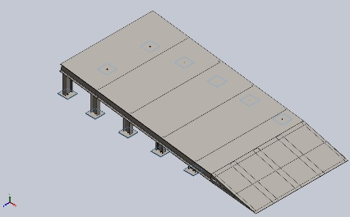
  Entities: | 11 face(s)
  Type: | Fixed Geometry
Resultant Forces
Components | X | Y | Z | Resultant
Reaction force(N) | 975.833 | 4,893.1 | 0.000465393 | 4,989.46
Reaction Moment(N.m) | 0 | 0 | 0 | 1e-33

Load name | Load Image | Load Details
Force-1 | 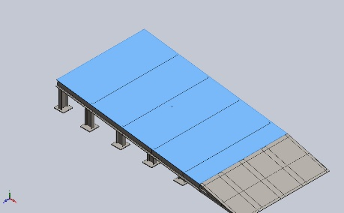
  Entities: | 1 face(s)
  Type: | Apply normal force
  Value: | 2,500 N
Force-2 | 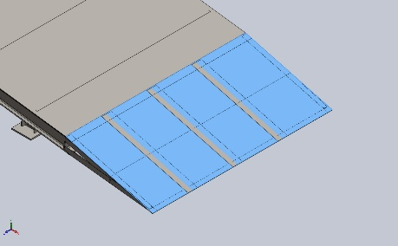
  Entities: | 1 face(s)
  Type: | Apply normal force
  Value: | 2,500 N

Connector Definitions
No Data

Interaction Information

Interaction | Interaction Image | Interaction Properties
Global Interaction | 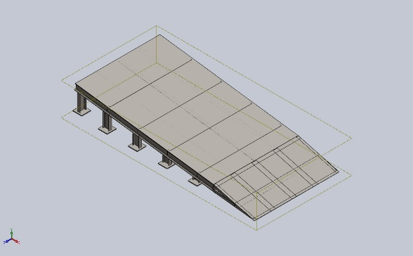
  Type: | Bonded
  Components: | 1 component(s)
  Options: | Independent mesh

Mesh information
Mesh type | Mixed Mesh
Mesher Used: | Blended curvature-based mesh
Jacobian points for High quality mesh | 16 Points
Jacobian check for shell | Off
Maximum element size | 60.1101 mm
Minimum element size | 60.1101 mm
Mesh Quality | High
Remesh failed parts independently | Off

Mesh information - Details
Total Nodes | 18893
Total Elements | 9230
Time to complete mesh(hh;mm;ss): | 00:00:11
Computer name:

Sensor Details
No Data

Resultant Forces

Reaction forces
Selection set | Units | Sum X | Sum Y | Sum Z | Resultant
Entire Model | N | 975.833 | 4,893.1 | 0.000465393 | 4,989.46

Reaction Moments
Selection set | Units | Sum X | Sum Y | Sum Z | Resultant
Entire Model | N.m | 0 | 0 | 0 | 1e-33

Free body forces
Selection set | Units | Sum X | Sum Y | Sum Z | Resultant
Entire Model | N | 0.175323 | 1.24407 | -0.000156403 | 1.25636

Free body moments
Selection set | Units | Sum X | Sum Y | Sum Z | Resultant
Entire Model | N.m | 0 | 0 | 0 | 1e-33

Beams

Beam Forces
Beam Name | Joints | Axial(N) | Shear1(N) | Shear2(N) | Moment1(N.m) | Moment2(N.m) | Torque(N.m)
Beam-1(Trim/Extend1[5]) | 1 | 0.853549 | -0.502709 | -0.274549 | 0.0016527 | -0.00643997 | 0.00760238
Beam-1(Trim/Extend1[5]) | 2 | -0.80298 | 0.374036 | 0.342845 | 0.0942514 | -0.141949 | -0.00313918
Beam-1(Trim/Extend1[5]) | 3 | 25.4994 | -11.4256 | -8.33377 | -1.92917 | 2.68111 | -0.0503772
Beam-1(Trim/Extend1[5]) | 4 | -0.853549 | 0.502709 | 0.274549 | 0.0240549 | -0.0406316 | -0.00760238
Beam-2(Cut-Extrude2) | 1 | 1.42755 | 0.439783 | -0.0520676 | -0.0115494 | -0.090998 | 0.00512708
Beam-2(Cut-Extrude2) | 2 | -0.981374 | 0.214168 | -0.0762117 | 0.0138425 | 0.0419888 | 0.00432488
Beam-2(Cut-Extrude2) | 3 | 0.981372 | -0.214177 | 0.0762145 | 0.0112285 | 0.0284657 | -0.00432496
Beam-2(Cut-Extrude2) | 4 | 5.29292 | 0.553961 | -0.0264289 | -0.0056559 | -0.0995685 | 0.00280588
Beam-2(Cut-Extrude2) | 5 | 4.66665 | -0.591318 | -0.02892 | -0.00624214 | 0.101747 | -0.000241669
Beam-3(Cut-Extrude4) | 1 | 13.2231 | -19.5742 | -17.2302 | -0.144947 | -0.99609 | -0.153585
Beam-3(Cut-Extrude4) | 2 | -24.1039 | -29.1171 | -15.8509 | -0.204372 | 2.87337 | -0.125462
Beam-3(Cut-Extrude4) | 3 | -29.5567 | 28.2909 | 16.7434 | 5.66417 | -6.90994 | -0.00884556
Beam-3(Cut-Extrude4) | 4 | -13.2231 | 19.5742 | 17.2302 | 6.53808 | -6.26677 | 0.153588
Beam-3(Cut-Extrude4) | 5 | -7.31635 | -20.7589 | -19.9988 | -1.04609 | 1.983 | 0.0800657
Beam-4(Trim/Extend1[1]) | 1 | 0.887915 | 0.197383 | -0.190465 | -0.00700991 | -0.0167126 | -0.00624274
Beam-4(Trim/Extend1[1]) | 2 | -0.881804 | -0.181976 | 0.232051 | 0.0722039 | 0.103189 | 0.00292408
Beam-4(Trim/Extend1[1]) | 3 | 11.1734 | 16.4278 | -11.1082 | -2.55647 | -3.84703 | 0.0410809
Beam-4(Trim/Extend1[1]) | 4 | -0.887915 | -0.197383 | 0.190465 | 0.0248442 | 0.0351947 | 0.00624274
Beam-5(Trim/Extend1[2]) | 1 | -0.388532 | 3.68529 | -0.0474402 | 0.015259 | 0.214376 | -0.0219233
Beam-5(Trim/Extend1[2]) | 2 | 0.388531 | -3.68529 | 0.0474149 | -0.000366528 | 0.943017 | 0.021924
Beam-5(Trim/Extend1[2]) | 3 | 58.6223 | 2.57187 | 30.9904 | 10.0582 | -0.211077 | 0.0746567
Beam-6(Trim/Extend1[4]) | 1 | -0.116735 | -3.86385 | 0.108677 | -0.00245173 | -0.255565 | 0.03229
Beam-6(Trim/Extend1[4]) | 2 | 0.116735 | 3.86385 | -0.108652 | -0.031673 | -0.957908 | -0.0322907
Beam-6(Trim/Extend1[4]) | 3 | 41.4015 | 10.7064 | 35.8967 | 12.093 | -5.98272 | -0.162536
Beam-7(Trim/Extend1[3]) | 1 | 1.13303 | 0.630394 | 0.150808 | -0.0213466 | 0.0235627 | 0.00672371
Beam-7(Trim/Extend1[3]) | 2 | -1.13303 | -0.630395 | -0.150805 | -0.0260148 | 0.174418 | -0.00672382
Beam-7(Trim/Extend1[3]) | 3 | -51.1189 | -23.7826 | -35.0203 | -11.9016 | 8.17924 | -0.0494339
Beam-8(C channel 100 X 10(1)) | 1 | 217.409 | 172.251 | 1,406.17 | 78.3887 | 8.17993 | -3.1012
Beam-8(C channel 100 X 10(1)) | 2 | -92.9585 | -264.482 | 968.954 | -66.5385 | -52.2156 | -4.30238
Beam-8(C channel 100 X 10(1)) | 3 | 618.81 | 151.594 | 1,653.31 | 104.296 | 86.5031 | -4.56661
Beam-8(C channel 100 X 10(1)) | 4 | 516.325 | 383.073 | 1,633.93 | 87.6584 | 96.0173 | -4.07746
Beam-8(C channel 100 X 10(1)) | 5 | 876.879 | 67.5702 | 1,770.89 | 109.4 | 104.768 | -3.63238
Beam-9(Angle iron 35 X 35 X 5(1)[1]) | 1 | -1.24328 | 0.924844 | -0.345825 | 0.0298528 | 0.0684206 | 0.00622445
Beam-9(Angle iron 35 X 35 X 5(1)[1]) | 2 | 1.18315 | -1.05352 | 0.405884 | 0.090387 | 0.186418 | -0.00367301
Beam-9(Angle iron 35 X 35 X 5(1)[1]) | 3 | -45.8136 | 0.369991 | 1.49995 | -0.032786 | -0.703001 | -0.0466692
Beam-9(Angle iron 35 X 35 X 5(1)[1]) | 4 | 1.24328 | -0.924844 | 0.345825 | -0.0100884 | -0.0155645 | -0.00622445
Beam-10(Angle iron 35 X 35 X 5(1)[2]) | 1 | -1.0641 | -0.783988 | -0.243607 | 0.0152934 | -0.0444447 | -0.00558203
Beam-10(Angle iron 35 X 35 X 5(1)[2]) | 2 | 1.0519 | 0.799396 | 0.283832 | 0.0665292 | -0.142502 | 0.00334879
Beam-10(Angle iron 35 X 35 X 5(1)[2]) | 3 | -40.6187 | -6.69481 | -2.16236 | -0.892142 | 2.14097 | 0.0365038
Beam-10(Angle iron 35 X 35 X 5(1)[2]) | 4 | 1.0641 | 0.783988 | 0.243607 | -0.00241866 | 0.00301058 | 0.00558203
Beam-11(Cut-Extrude5[5]) | 1 | -3,088.23 | 1,185.91 | 189.978 | 8.8883 | 57.9578 | 0.848069
Beam-11(Cut-Extrude5[5]) | 2 | -2,718.25 | 121.619 | -46.9107 | -3.2043 | 117.502 | 0.45584
Beam-11(Cut-Extrude5[5]) | 3 | -347.557 | -127.64 | 19.8142 | 1.59998 | 23.0449 | -0.122193
Beam-11(Cut-Extrude5[5]) | 4 | -3,357.31 | -223.302 | -10.8059 | 0.656385 | 199.106 | 1.10368
Beam-11(Cut-Extrude5[5]) | 5 | 9.23858 | 51.6546 | -2.83993 | 0.267826 | 2.452 | 0.0397765
Beam-11(Cut-Extrude5[5]) | 6 | -1,394.91 | -265.455 | 29.0132 | 3.08557 | 86.5706 | 0.0950098
Beam-12(C channel 100 X 10(1)[4]) | 1 | 1,597.23 | 328.887 | -29.6848 | -8.61781 | 100.115 | 0.197533
Beam-12(C channel 100 X 10(1)[4]) | 2 | -840.784 | 479.03 | 39.2579 | -6.43425 | 24.9317 | 0.328466
Beam-12(C channel 100 X 10(1)[4]) | 3 | 1,615.97 | -322.447 | -0.749349 | -3.46018 | 208.062 | -0.0992262
Beam-12(C channel 100 X 10(1)[4]) | 4 | 845.094 | 507.202 | 10.0122 | 1.77278 | -27.1652 | 0.526002
Beam-12(C channel 100 X 10(1)[4]) | 5 | 840.784 | -479.029 | -39.2709 | -6.81883 | 136.741 | -0.328414
Beam-13(Cut-Extrude5[1]) | 1 | -1,808 | 603.357 | -269.313 | -25.4937 | 18.7665 | 0.365092
Beam-13(Cut-Extrude5[1]) | 2 | -3,023.09 | 1,127.25 | 83.8173 | 6.88674 | 113.356 | -0.460023
Beam-13(Cut-Extrude5[1]) | 3 | -86.744 | -109.067 | 20.4151 | 1.95279 | 22.916 | 0.148337
Beam-13(Cut-Extrude5[1]) | 4 | -332.275 | -182.416 | 1.22102 | -0.702295 | 30.2721 | 0.17713
Beam-13(Cut-Extrude5[1]) | 5 | -61.5815 | 40.7926 | 18.3579 | -1.93214 | 11.8435 | 0.0552368
Beam-13(Cut-Extrude5[1]) | 6 | -3,126.71 | -587.042 | -4.80416 | 3.66111 | 161.354 | -1.08642
Beam-14(Cut-Extrude5[3]) | 1 | -1,697.76 | 428.457 | -9.65781 | -1.25765 | 15.3272 | -0.0307331
Beam-14(Cut-Extrude5[3]) | 2 | -2,093.33 | 60.1163 | -1.73386 | -0.803989 | 126.291 | -0.0342428
Beam-14(Cut-Extrude5[3]) | 3 | -319.079 | -95.3882 | -0.136062 | -0.119598 | 35.3622 | 0.00716019
Beam-14(Cut-Extrude5[3]) | 4 | -2,059.45 | -123.082 | -0.233919 | -0.325399 | 163.535 | -0.0228078
Beam-14(Cut-Extrude5[3]) | 5 | 319.079 | 95.3883 | 0.136046 | 0.0504288 | 13.1308 | -0.00715996
Beam-14(Cut-Extrude5[3]) | 6 | -1,220.63 | -180.595 | -2.31662 | -0.853013 | 115.049 | -0.000926873
Beam-15(C channel 100 X 10(1)[1]) | 1 | -257.718 | -40.0406 | 11.5497 | 1.48115 | -5.25105 | -0.0282917
Beam-15(C channel 100 X 10(1)[1]) | 2 | 44.3082 | -59.6326 | -4.5322 | 0.468347 | -13.3371 | 0.0424124
Beam-15(C channel 100 X 10(1)[1]) | 3 | -236.299 | 59.4438 | -9.10887 | -1.77829 | -18.6507 | 0.0219466
Beam-15(C channel 100 X 10(1)[1]) | 4 | -78.8268 | -61.8365 | -2.6756 | 0.0429688 | 7.91489 | 0.0258613
Beam-15(C channel 100 X 10(1)[1]) | 5 | -44.3082 | 59.6326 | 4.5322 | 1.06127 | -6.78883 | -0.0424123
Beam-16(Cut-Extrude2[6]) | 1 | 2.43185 | -27.7918 | 37.0859 | -5.71901 | -7.27259 | 0.0111882
Beam-16(Cut-Extrude2[6]) | 2 | -2.43185 | 27.7918 | -37.0859 | -5.40675 | -1.06495 | -0.0111882
Beam-17(Cut-Extrude2[8]) | 1 | 30.63 | 419.101 | 37.6388 | 5.87772 | -49.1925 | 0.0113192
Beam-17(Cut-Extrude2[8]) | 2 | -30.6302 | -419.101 | -37.6388 | 4.83733 | -70.1176 | -0.0113196
Beam-18(Cut-Extrude2[9]) | 1 | -516.753 | -925.525 | -27.4377 | 5.17407 | -101.679 | -0.106393
Beam-18(Cut-Extrude2[9]) | 2 | 516.753 | 925.525 | 27.4377 | -0.55121 | -54.2586 | 0.106393
Beam-19(Cut-Extrude2[5]) | 1 | -54.3133 | -22.841 | 59.0475 | -9.23163 | -5.27192 | -0.019885
Beam-19(Cut-Extrude2[5]) | 2 | 54.3133 | 22.8408 | -59.0475 | -8.48262 | -1.58034 | 0.0198859
Beam-20(Cut-Extrude2[10]) | 1 | 3,207.47 | 1,723.46 | 1,540.44 | -49.305 | -230.838 | -0.0276896
Beam-20(Cut-Extrude2[10]) | 2 | -3,207.47 | -1,723.46 | -1,540.44 | -108.942 | 407.886 | 0.0276896
Beam-21(C channel 100 X 10(1)[3]) | 1 | 1,314.47 | 288.76 | 13.8178 | -1.42762 | 133.282 | -0.112429
Beam-21(C channel 100 X 10(1)[3]) | 2 | 412.854 | 1,219.3 | 146.888 | -29.1984 | 233.392 | -1.07633
Beam-21(C channel 100 X 10(1)[3]) | 3 | 1,225.51 | -390.356 | -19.198 | -7.56351 | 233.393 | 0.169097
Beam-21(C channel 100 X 10(1)[3]) | 4 | -134.364 | 1,099.03 | 105.848 | 17.8002 | -168.446 | -0.961901
Beam-21(C channel 100 X 10(1)[3]) | 5 | -412.854 | -1,219.31 | -146.859 | -20.372 | 178.122 | 1.07647
Beam-22(Cut-Extrude2[11]) | 1 | 0 | 0 | 0 | 0 | 0 | 0
Beam-22(Cut-Extrude2[11]) | 2 | 0 | 0 | 0 | 0 | 0 | 0
Beam-23(Cut-Extrude5[2]) | 1 | -1,989.5 | 519.828 | 87.8457 | 8.30036 | 36.2745 | -0.161062
Beam-23(Cut-Extrude5[2]) | 2 | -3,088.81 | 1,151.27 | -73.5784 | -7.97563 | 115.4 | 0.495468
Beam-23(Cut-Extrude5[2]) | 3 | -3.13058 | -77.7688 | -19.2427 | -1.64372 | 16.3257 | -0.19332
Beam-23(Cut-Extrude5[2]) | 4 | -54.8703 | 5.01647 | -25.77 | 2.67299 | 5.4111 | -0.0134899
Beam-23(Cut-Extrude5[2]) | 5 | -3,542.06 | -989.098 | -3.47191 | -0.955901 | 233.78 | 1.08874
Beam-23(Cut-Extrude5[2]) | 6 | -256.708 | -122.106 | -9.76197 | -1.06895 | 11.8861 | -0.173515
Beam-24(Cut-Extrude2[7]) | 1 | -231.109 | -36.3518 | 66.7041 | -9.1247 | -6.86491 | -0.00879654
Beam-24(Cut-Extrude2[7]) | 2 | 231.109 | 36.3518 | -66.7041 | -10.8865 | -4.04064 | 0.00879612
Beam-25(Sb beam 100 X 8(1)[4]) | 1 | 99.0144 | -20.5244 | -4.70847 | -0.346408 | 1.59954 | 0.0103188
Beam-25(Sb beam 100 X 8(1)[4]) | 2 | -68.3402 | 14.1371 | 5.46498 | -0.749175 | 4.86673 | 0.0534768
Beam-25(Sb beam 100 X 8(1)[4]) | 3 | 78.3774 | -8.39598 | 3.60174 | 0.864772 | 3.0924 | -0.0163565
Beam-25(Sb beam 100 X 8(1)[4]) | 4 | 17.6205 | -9.33227 | 5.42143 | 1.17861 | 2.42554 | 0.0435284
Beam-25(Sb beam 100 X 8(1)[4]) | 5 | 68.3402 | -14.1371 | -5.46498 | -0.958632 | -0.448886 | -0.0534768
Beam-26(Cut-Extrude2[12]) | 1 | 13.0556 | 259.672 | 0.64592 | -0.825588 | -30.8281 | 0.0138462
Beam-26(Cut-Extrude2[12]) | 2 | -13.0557 | -259.672 | -0.64592 | 1.00947 | -43.097 | -0.0138456
Beam-27(Cut-Extrude2[13]) | 1 | -736.244 | -667.904 | -184.018 | 14.2416 | -63.4325 | -0.00355881
Beam-27(Cut-Extrude2[13]) | 2 | 736.244 | 667.904 | 184.018 | 16.7636 | -49.1031 | 0.00355881
Beam-28(Cut-Extrude5[4]) | 1 | -2,855.29 | 538.837 | 40.9382 | 4.54623 | 65.2534 | 0.236816
Beam-28(Cut-Extrude5[4]) | 2 | -2,579.75 | 12.6203 | 46.1855 | 2.93696 | 143.866 | -0.790352
Beam-28(Cut-Extrude5[4]) | 3 | -323.512 | -120.812 | -20.8707 | -1.61182 | 21.9593 | 0.0932559
Beam-28(Cut-Extrude5[4]) | 4 | -3,134.5 | -535.332 | 43.0795 | 0.927563 | 239.391 | -1.26744
Beam-28(Cut-Extrude5[4]) | 5 | 1.12869 | 30.3703 | -18.7115 | 0.613524 | 1.22807 | -0.0869893
Beam-28(Cut-Extrude5[4]) | 6 | -1,257.43 | -230.782 | -29.1587 | -2.84627 | 76.8245 | -0.0515964
Beam-29(Cut-Extrude2[14]) | 1 | -3,265.3 | -1,687.42 | 1,203.72 | 117.947 | 407.484 | -0.194715
Beam-29(Cut-Extrude2[14]) | 2 | 3,265.3 | 1,687.42 | -1,203.72 | 66.4286 | -149.02 | 0.194715
Beam-30(Cut-Extrude2[15]) | 1 | -1.71859e-11 | -2.06791e-11 | -9.00436e-14 | 3.05586e-15 | -5.54296e-13 | -4.86529e-17
Beam-30(Cut-Extrude2[15]) | 2 | 1.48906e-12 | 3.15029e-12 | 1.29232e-13 | -6.17431e-16 | 8.38784e-14 | 8.37265e-17
Beam-31(Cut-Extrude5[6]) | 1 | -1,625.09 | 196.066 | -167.44 | -9.38323 | 22.27 | -0.15993
Beam-31(Cut-Extrude5[6]) | 2 | -1,822.16 | 24.6951 | -30.5374 | -2.00031 | 134.24 | -0.0830688
Beam-31(Cut-Extrude5[6]) | 3 | -909.013 | -198.977 | -13.7671 | -1.11789 | 35.1876 | -0.0115118
Beam-31(Cut-Extrude5[6]) | 4 | -2,479.2 | -143.889 | -10.6641 | -0.307514 | 159.651 | -0.319195
Beam-31(Cut-Extrude5[6]) | 5 | -185.346 | 108.158 | 7.2814 | -0.568958 | 5.74957 | 0.0434366
Beam-31(Cut-Extrude5[6]) | 6 | -2,047.19 | -218.178 | 9.29378 | -0.162063 | 111.3 | 0.0490068
Beam-32(C channel 100 X 10(1)[2]) | 1 | -190.261 | 170.532 | 30.0888 | 3.56831 | -8.76842 | -0.230652
Beam-32(C channel 100 X 10(1)[2]) | 2 | 103.016 | -35.7634 | 9.46632 | -0.844215 | -9.0266 | -0.321083
Beam-32(C channel 100 X 10(1)[2]) | 3 | -148.519 | -142.478 | -26.3933 | -5.09048 | 46.4365 | 0.261393
Beam-32(C channel 100 X 10(1)[2]) | 4 | -224.708 | 25.576 | 33.0011 | 6.48761 | -16.0194 | -0.40268
Beam-32(C channel 100 X 10(1)[2]) | 5 | -103.016 | 35.7634 | -9.46635 | -2.35067 | -3.04353 | 0.32108

Beam Stresses
Beam Name | Joints | Axial(N/m^2) | Bending Dir1(N/m^2) | Bending Dir2(N/m^2) | Torsional (N/m^2) | Upper bound axial and bending(N/m^2)
Beam-1(Trim/Extend1[5]) | 1 | -2,670.39 | 2,396.05 | -6,199.64 | -85,630.6 | 11,266.1
Beam-1(Trim/Extend1[5]) | 2 | -2,512.18 | 12,686.1 | 98,329.4 | -35,358.7 | 113,528
Beam-1(Trim/Extend1[5]) | 3 | 79,776.7 | -408,362 | -1.75849e+06 | -567,431 | 2.24663e+06
Beam-1(Trim/Extend1[5]) | 4 | -2,670.39 | 319.531 | 30,083.4 | -85,630.6 | 33,073.4
Beam-2(Cut-Extrude2) | 1 | 16,499.9 | -594,820 | 635,244 | 451,575 | 1.24656e+06
Beam-2(Cut-Extrude2) | 2 | 11,342.9 | -569,728 | 425,632 | -380,920 | 1.0067e+06
Beam-2(Cut-Extrude2) | 3 | 11,342.8 | 450,199 | -317,257 | -380,927 | 778,798
Beam-2(Cut-Extrude2) | 4 | 61,176.4 | -408,713 | 586,406 | 247,132 | 1.05629e+06
Beam-2(Cut-Extrude2) | 5 | 53,937.7 | 708.494 | -412,110 | -21,285.4 | 466,757
Beam-3(Cut-Extrude4) | 1 | -18,482.2 | 194,551 | -221,587 | 1.2151e+06 | 434,620
Beam-3(Cut-Extrude4) | 2 | -33,690.4 | 319,968 | -524,364 | -992,609 | 878,022
Beam-3(Cut-Extrude4) | 3 | -41,311.8 | 1.23516e+06 | 306,755 | -69,982.7 | 1.58323e+06
Beam-3(Cut-Extrude4) | 4 | -18,482.2 | 1.66319e+06 | 19,725.1 | 1.21513e+06 | 1.7014e+06
Beam-3(Cut-Extrude4) | 5 | -10,226.2 | -129,924 | -194,918 | 633,449 | 335,068
Beam-4(Trim/Extend1[1]) | 1 | -2,777.9 | -3,135.92 | -14,285.6 | 70,340.4 | 20,199.5
Beam-4(Trim/Extend1[1]) | 2 | -2,758.78 | 13,400.6 | -69,034.7 | 32,947.2 | 85,194.1
Beam-4(Trim/Extend1[1]) | 3 | 34,956.8 | -346,222 | 2.66345e+06 | 462,881 | 3.04463e+06
Beam-4(Trim/Extend1[1]) | 4 | -2,777.9 | 4,816.95 | -23,401.6 | 70,340.4 | 30,996.5
Beam-5(Trim/Extend1[2]) | 1 | 453.747 | -26,713.2 | 41,971.2 | 147,331 | 69,138.1
Beam-5(Trim/Extend1[2]) | 2 | 453.746 | 104,829 | -177,119 | 147,336 | 282,403
Beam-5(Trim/Extend1[2]) | 3 | 68,462 | 1.86611e+06 | -1.07919e+06 | 501,716 | 3.01377e+06
Beam-6(Trim/Extend1[4]) | 1 | 136.329 | 28,888.8 | -48,284.5 | -216,999 | 77,309.7
Beam-6(Trim/Extend1[4]) | 2 | 136.329 | -112,505 | 183,481 | -217,003 | 296,122
Beam-6(Trim/Extend1[4]) | 3 | 48,350.7 | 1.60636e+06 | -221,241 | -1.09229e+06 | 1.87595e+06
Beam-7(Trim/Extend1[3]) | 1 | -1,323.21 | 1,389.25 | 2,052.09 | -45,185.4 | 4,764.55
Beam-7(Trim/Extend1[3]) | 2 | -1,323.21 | 14,514.4 | -29,873.3 | -45,186.1 | 45,710.9
Beam-7(Trim/Extend1[3]) | 3 | -59,699.2 | -1.32606e+06 | -212,703 | -332,211 | 1.59846e+06
Beam-8(C channel 100 X 10(1)) | 1 | 165,939 | 9.9669e+06 | -204,567 | -9.23051e+06 | 1.03374e+07
Beam-8(C channel 100 X 10(1)) | 2 | 70,951.2 | 8.46018e+06 | -1.30583e+06 | 1.28057e+07 | 9.83695e+06
Beam-8(C channel 100 X 10(1)) | 3 | 472,311 | 1.32609e+07 | -2.1633e+06 | -1.35922e+07 | 1.58966e+07
Beam-8(C channel 100 X 10(1)) | 4 | 394,088 | 1.11455e+07 | -2.40123e+06 | -1.21363e+07 | 1.39408e+07
Beam-8(C channel 100 X 10(1)) | 5 | 669,283 | 1.39099e+07 | -2.62008e+06 | -1.08115e+07 | 1.71992e+07
Beam-9(Angle iron 35 X 35 X 5(1)[1]) | 1 | 3,889.68 | 11,530.4 | 57,719.3 | -70,103.9 | 73,139.3
Beam-9(Angle iron 35 X 35 X 5(1)[1]) | 2 | 3,701.58 | -21,163.2 | -151,263 | -41,367.9 | 176,127
Beam-9(Angle iron 35 X 35 X 5(1)[1]) | 3 | -143,331 | 428,784 | 774,607 | -525,620 | 1.34672e+06
Beam-9(Angle iron 35 X 35 X 5(1)[1]) | 4 | 3,889.68 | -1,112.26 | 10,944.7 | -70,103.9 | 15,946.7
Beam-10(Angle iron 35 X 35 X 5(1)[2]) | 1 | 3,329.13 | 12,132.4 | -40,209.6 | 62,868.5 | 55,671.1
Beam-10(Angle iron 35 X 35 X 5(1)[2]) | 2 | 3,290.96 | -19,082.9 | 117,329 | 37,716.3 | 139,702
Beam-10(Angle iron 35 X 35 X 5(1)[2]) | 3 | -127,078 | 408,367 | -1.83394e+06 | 411,130 | 2.36939e+06
Beam-10(Angle iron 35 X 35 X 5(1)[2]) | 4 | 3,329.13 | -744.478 | -1,807.29 | 62,868.5 | 5,880.89
Beam-11(Cut-Extrude5[5]) | 1 | -2.83316e+06 | 1.84119e+06 | -1.65827e+06 | 2.59734e+06 | 6.33262e+06
Beam-11(Cut-Extrude5[5]) | 2 | -2.49373e+06 | -663,761 | -3.36194e+06 | 1.39608e+06 | 6.51943e+06
Beam-11(Cut-Extrude5[5]) | 3 | -318,851 | 331,432 | -659,353 | -374,235 | 1.30964e+06
Beam-11(Cut-Extrude5[5]) | 4 | -3.08002e+06 | 135,968 | -5.69675e+06 | 3.38018e+06 | 8.91274e+06
Beam-11(Cut-Extrude5[5]) | 5 | -8,475.52 | -55,479.3 | 70,155.9 | -121,821 | 134,111
Beam-11(Cut-Extrude5[5]) | 6 | -1.2797e+06 | 639,166 | -2.47693e+06 | 290,982 | 4.39579e+06
Beam-12(C channel 100 X 10(1)[4]) | 1 | 1.2191e+06 | -1.09573e+06 | -2.50371e+06 | 589,708 | 4.81853e+06
Beam-12(C channel 100 X 10(1)[4]) | 2 | 641,733 | 818,098 | 623,499 | -980,590 | 2.08333e+06
Beam-12(C channel 100 X 10(1)[4]) | 3 | 1.2334e+06 | -439,951 | -5.20327e+06 | -296,226 | 6.87662e+06
Beam-12(C channel 100 X 10(1)[4]) | 4 | 645,023 | 225,404 | 679,354 | 1.57031e+06 | 1.54978e+06
Beam-12(C channel 100 X 10(1)[4]) | 5 | 641,733 | -866,996 | -3.41965e+06 | -980,434 | 4.92838e+06
Beam-13(Cut-Extrude5[1]) | 1 | -1.65867e+06 | -5.28096e+06 | -536,941 | 1.11815e+06 | 7.47657e+06
Beam-13(Cut-Extrude5[1]) | 2 | -2.7734e+06 | 1.42657e+06 | -3.2433e+06 | -1.40889e+06 | 7.44327e+06
Beam-13(Cut-Extrude5[1]) | 3 | -79,579.4 | 404,514 | -655,666 | 454,304 | 1.13976e+06
Beam-13(Cut-Extrude5[1]) | 4 | -304,831 | -145,478 | -866,134 | 542,487 | 1.31644e+06
Beam-13(Cut-Extrude5[1]) | 5 | 56,495.2 | 400,238 | 338,861 | -169,171 | 795,594
Beam-13(Cut-Extrude5[1]) | 6 | -2.86846e+06 | 758,388 | -4.61661e+06 | -3.32731e+06 | 8.24345e+06
Beam-14(Cut-Extrude5[3]) | 1 | -1.55754e+06 | -260,519 | -438,536 | -94,190.7 | 2.25659e+06
Beam-14(Cut-Extrude5[3]) | 2 | -1.92044e+06 | -166,544 | -3.61339e+06 | -104,947 | 5.70037e+06
Beam-14(Cut-Extrude5[3]) | 3 | -292,724 | -24,774.3 | -1.01177e+06 | 21,944.6 | 1.32927e+06
Beam-14(Cut-Extrude5[3]) | 4 | -1.88935e+06 | -67,405.6 | -4.67901e+06 | -69,901.3 | 6.63577e+06
Beam-14(Cut-Extrude5[3]) | 5 | -292,724 | -10,446.2 | 375,694 | 21,943.9 | 678,864
Beam-14(Cut-Extrude5[3]) | 6 | -1.11982e+06 | -176,699 | -3.29175e+06 | -2,840.68 | 4.58827e+06
Beam-15(C channel 100 X 10(1)[1]) | 1 | -196,705 | 188,324 | 131,320 | -84,458.7 | 516,349
Beam-15(C channel 100 X 10(1)[1]) | 2 | -33,818.5 | -59,549 | -333,539 | -126,613 | 426,906
Beam-15(C channel 100 X 10(1)[1]) | 3 | -180,357 | -226,105 | 466,422 | 65,516.9 | 872,884
Beam-15(C channel 100 X 10(1)[1]) | 4 | -60,165 | 5,463.44 | -197,938 | 77,203.3 | 263,566
Beam-15(C channel 100 X 10(1)[1]) | 5 | -33,818.5 | 134,938 | 169,777 | -126,613 | 338,533
Beam-16(Cut-Extrude2[6]) | 1 | -2,230.99 | 1.18468e+06 | -208,081 | -34,277.5 | 1.39499e+06
Beam-16(Cut-Extrude2[6]) | 2 | -2,230.99 | -1.11999e+06 | 30,470 | -34,277.5 | 1.15269e+06
Beam-17(Cut-Extrude2[8]) | 1 | 28,100.1 | 1.21755e+06 | 1.40748e+06 | 34,679 | 2.65313e+06
Beam-17(Cut-Extrude2[8]) | 2 | 28,100.3 | -1.00204e+06 | -2.00618e+06 | 34,680 | 3.03632e+06
Beam-18(Cut-Extrude2[9]) | 1 | 474,072 | -1.07179e+06 | -2.90921e+06 | 325,959 | 4.45507e+06
Beam-18(Cut-Extrude2[9]) | 2 | 474,072 | -114,182 | 1.55243e+06 | 325,959 | 2.14068e+06
Beam-19(Cut-Extrude2[5]) | 1 | 49,827.3 | 1.91231e+06 | -150,838 | 60,922.3 | 2.11297e+06
Beam-19(Cut-Extrude2[5]) | 2 | 49,827.3 | -1.75715e+06 | 45,216.2 | 60,925 | 1.85219e+06
Beam-20(Cut-Extrude2[10]) | 1 | -2.94255e+06 | 1.02134e+07 | -6.60465e+06 | 84,833.3 | 1.97606e+07
Beam-20(Cut-Extrude2[10]) | 2 | -2.94255e+06 | -2.25671e+07 | -1.16703e+07 | 84,833.3 | 3.71799e+07
Beam-21(C channel 100 X 10(1)[3]) | 1 | 1.00328e+06 | -181,516 | -3.33317e+06 | -335,640 | 4.51796e+06
Beam-21(C channel 100 X 10(1)[3]) | 2 | -315,113 | 3.7125e+06 | 5.83674e+06 | 3.21323e+06 | 9.86436e+06
Beam-21(C channel 100 X 10(1)[3]) | 3 | 935,377 | -961,678 | -5.83677e+06 | 504,815 | 7.73383e+06
Beam-21(C channel 100 X 10(1)[3]) | 4 | -102,554 | 2.26325e+06 | 4.21256e+06 | -2.87162e+06 | 6.57836e+06
Beam-21(C channel 100 X 10(1)[3]) | 5 | -315,113 | -2.59024e+06 | -4.45453e+06 | 3.21365e+06 | 7.35989e+06
Beam-22(Cut-Extrude2[11]) | 1 | 0 | 0 | 0 | 0 | 0
Beam-22(Cut-Extrude2[11]) | 2 | 0 | 0 | 0 | 0 | 0
Beam-23(Cut-Extrude5[2]) | 1 | -1.82518e+06 | 1.7194e+06 | -1.03787e+06 | -493,275 | 4.58245e+06
Beam-23(Cut-Extrude5[2]) | 2 | -2.83369e+06 | -1.65213e+06 | -3.3018e+06 | 1.51744e+06 | 7.78761e+06
Beam-23(Cut-Extrude5[2]) | 3 | -2,872.01 | -340,492 | -467,106 | -592,070 | 810,469
Beam-23(Cut-Extrude5[2]) | 4 | 50,338.3 | -553,702 | 154,821 | 41,314.8 | 758,860
Beam-23(Cut-Extrude5[2]) | 5 | -3.24951e+06 | -198,012 | -6.68882e+06 | 3.33442e+06 | 1.01363e+07
Beam-23(Cut-Extrude5[2]) | 6 | -235,505 | -221,430 | -340,080 | -531,415 | 797,015
Beam-24(Cut-Extrude2[7]) | 1 | 212,020 | 1.89016e+06 | -196,416 | 26,950.2 | 2.29859e+06
Beam-24(Cut-Extrude2[7]) | 2 | 212,020 | -2.25511e+06 | 115,609 | 26,948.9 | 2.58274e+06
Beam-25(Sb beam 100 X 8(1)[4]) | 1 | 90,836.3 | -71,757.3 | -45,765.4 | 31,606.7 | 208,359
Beam-25(Sb beam 100 X 8(1)[4]) | 2 | 62,695.7 | 155,190 | 139,245 | -163,801 | 357,130
Beam-25(Sb beam 100 X 8(1)[4]) | 3 | 71,903.8 | 179,135 | -88,478.8 | -50,100.4 | 339,518
Beam-25(Sb beam 100 X 8(1)[4]) | 4 | 16,165.1 | 244,145 | -69,398.7 | 133,329 | 329,709
Beam-25(Sb beam 100 X 8(1)[4]) | 5 | 62,695.7 | -198,578 | 12,843.4 | -163,801 | 274,117
Beam-26(Cut-Extrude2[12]) | 1 | 11,977.2 | -171,018 | 882,043 | 42,420.9 | 1.06504e+06
Beam-26(Cut-Extrude2[12]) | 2 | 11,977.4 | -209,109 | -1.23308e+06 | 42,419.1 | 1.45416e+06
Beam-27(Cut-Extrude2[13]) | 1 | 675,434 | -2.95011e+06 | -1.81491e+06 | 10,903.2 | 5.44046e+06
Beam-27(Cut-Extrude2[13]) | 2 | 675,434 | 3.47254e+06 | 1.40492e+06 | 10,903.2 | 5.5529e+06
Beam-28(Cut-Extrude5[4]) | 1 | -2.61946e+06 | 941,738 | -1.86701e+06 | 725,283 | 5.4282e+06
Beam-28(Cut-Extrude5[4]) | 2 | -2.36668e+06 | 608,382 | -4.11624e+06 | -2.42057e+06 | 7.09131e+06
Beam-28(Cut-Extrude5[4]) | 3 | -296,792 | -333,884 | -628,291 | 285,610 | 1.25897e+06
Beam-28(Cut-Extrude5[4]) | 4 | -2.87561e+06 | 192,142 | -6.84936e+06 | -3.88173e+06 | 9.91711e+06
Beam-28(Cut-Extrude5[4]) | 5 | -1,035.47 | -127,090 | 35,137 | 266,417 | 163,262
Beam-28(Cut-Extrude5[4]) | 6 | -1.15357e+06 | -589,596 | -2.19808e+06 | -158,022 | 3.94124e+06
Beam-29(Cut-Extrude2[14]) | 1 | -2.9956e+06 | 2.44324e+07 | -1.16588e+07 | -596,554 | 3.90868e+07
Beam-29(Cut-Extrude2[14]) | 2 | -2.9956e+06 | -1.37605e+07 | -4.2637e+06 | -596,554 | 2.10198e+07
Beam-30(Cut-Extrude2[15]) | 1 | 1.03284e-07 | -2.44869e-08 | -5.40542e-07 | 8.72444e-10 | 6.68313e-07
Beam-30(Cut-Extrude2[15]) | 2 | -8.94899e-09 | 4.94754e-09 | 8.17971e-08 | -1.50138e-09 | 9.56936e-08
Beam-31(Cut-Extrude5[6]) | 1 | -1.49087e+06 | -1.94371e+06 | -637,180 | -489,810 | 4.07176e+06
Beam-31(Cut-Extrude5[6]) | 2 | -1.67166e+06 | -414,358 | -3.84084e+06 | -254,410 | 5.92686e+06
Beam-31(Cut-Extrude5[6]) | 3 | -833,933 | -231,567 | -1.00678e+06 | -35,256.4 | 2.07228e+06
Beam-31(Cut-Extrude5[6]) | 4 | -2.27443e+06 | -63,700.7 | -4.56788e+06 | -977,582 | 6.90601e+06
Beam-31(Cut-Extrude5[6]) | 5 | 170,038 | 117,858 | 164,505 | -133,031 | 452,400
Beam-31(Cut-Extrude5[6]) | 6 | -1.8781e+06 | -33,570.8 | -3.18449e+06 | 150,091 | 5.09616e+06
Beam-32(C channel 100 X 10(1)[2]) | 1 | -145,218 | 453,701 | 219,283 | -688,561 | 818,203
Beam-32(C channel 100 X 10(1)[2]) | 2 | -78,627.7 | 107,340 | -225,740 | 958,523 | 411,707
Beam-32(C channel 100 X 10(1)[2]) | 3 | -113,358 | -647,240 | -1.1613e+06 | 780,333 | 1.9219e+06
Beam-32(C channel 100 X 10(1)[2]) | 4 | -171,510 | 824,883 | 400,618 | -1.20211e+06 | 1.39701e+06
Beam-32(C channel 100 X 10(1)[2]) | 5 | -78,627.7 | -298,882 | 76,113.6 | 958,516 | 453,623

Study Results

Name | Type | Min | Max
Stress1 | VON: von Mises Stress | 0.000e+00N/m^2  Node: 17610 | 1.285e+08N/m^2  Node: 14651
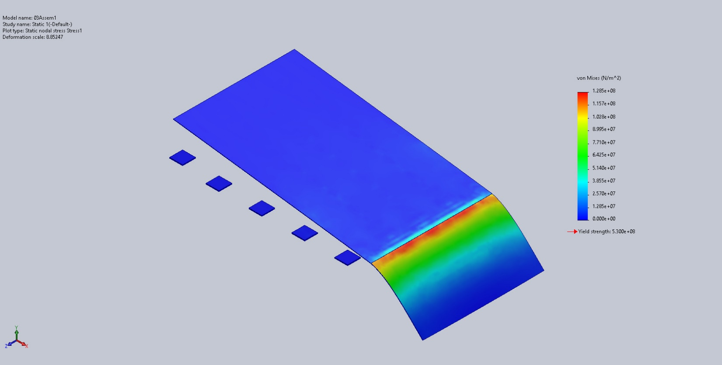
03Assem1-Static 1-Stress-Stress1

Name | Type | Min | Max
Displacement1 | URES: Resultant Displacement | 0.000e+00mm  Node: 16450 | 3.537e+01mm  Node: 14156
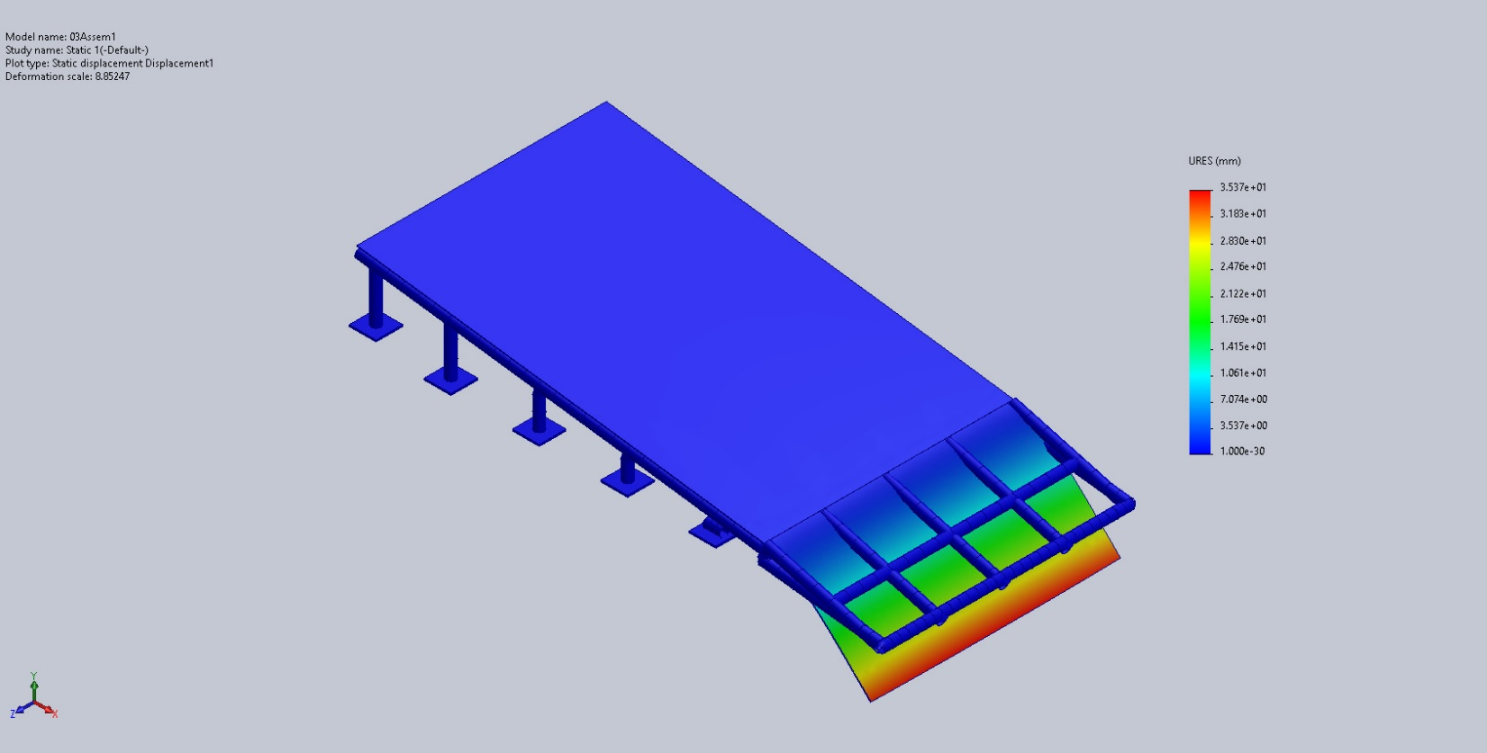
03Assem1-Static 1-Displacement-Displacement1

Name | Type | Min | Max
Strain1 | ESTRN: Equivalent Strain | 0.000e+00  Element: 8446 | 3.714e-04  Element: 6297
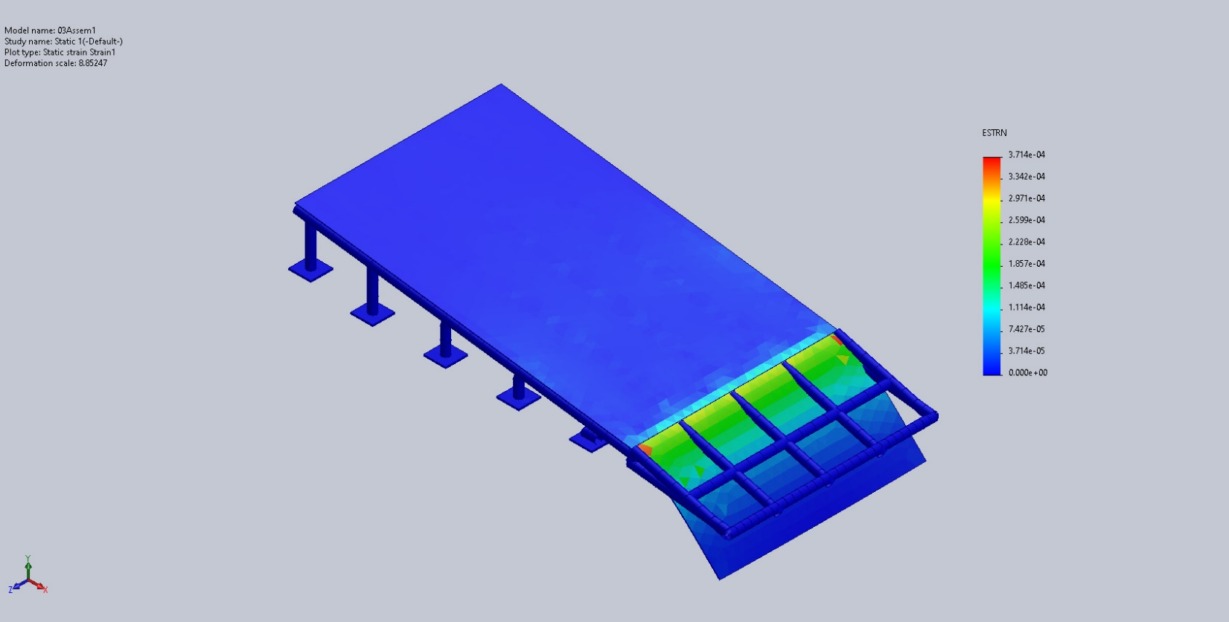
03Assem1-Static 1-Strain-Strain1

Conclusion

